**Entity/Definition Matrix:**

|  |  |
| --- | --- |
| **Entity** | **Business Definition** |
| Component | Any hardware item in inventory that can be installed in a system and the company handles warranty issue for. i.e. Hard Drive, RAM, etc.  Multiple components together form a equipment. |
| Client | A customer who has a contract for services with the company. |
| Equipment | Any device such as printer PC, router, hub, etc. that the company ensures is operational. |
| Software configuration Details | Information about client’s system which is a weak entity used for connecting client with SQL Server, Network Server, DSL Line and Router. |
| SQL Server Details | Consist of SQL Server details such as LAN IP, usernames and passwords. |
| Network Server Details | Consist of Network Server details such as LAN IP, username and password. |
| DSL Line Details | Contains the DSL IP for DSL Line. |
| Router Details | Consist of Router details such as LAN IP, username and password |

**Assumptions:**

1. One Equipment may consist of many components. One component will be allocated to only one equipment.
2. One Equipment can be owned by only one client. One client can own many equipment.
3. One client can have many software configurations (many Routers, SQL Servers, DSL servers and Network servers). One Software configuration can be present for many clients.

**Context Data Model:**

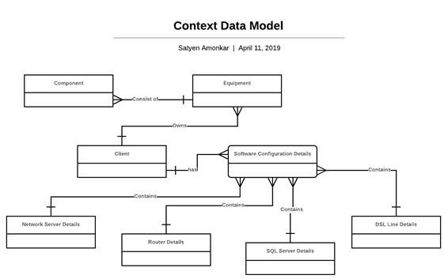

**Key-Based Data Model:** 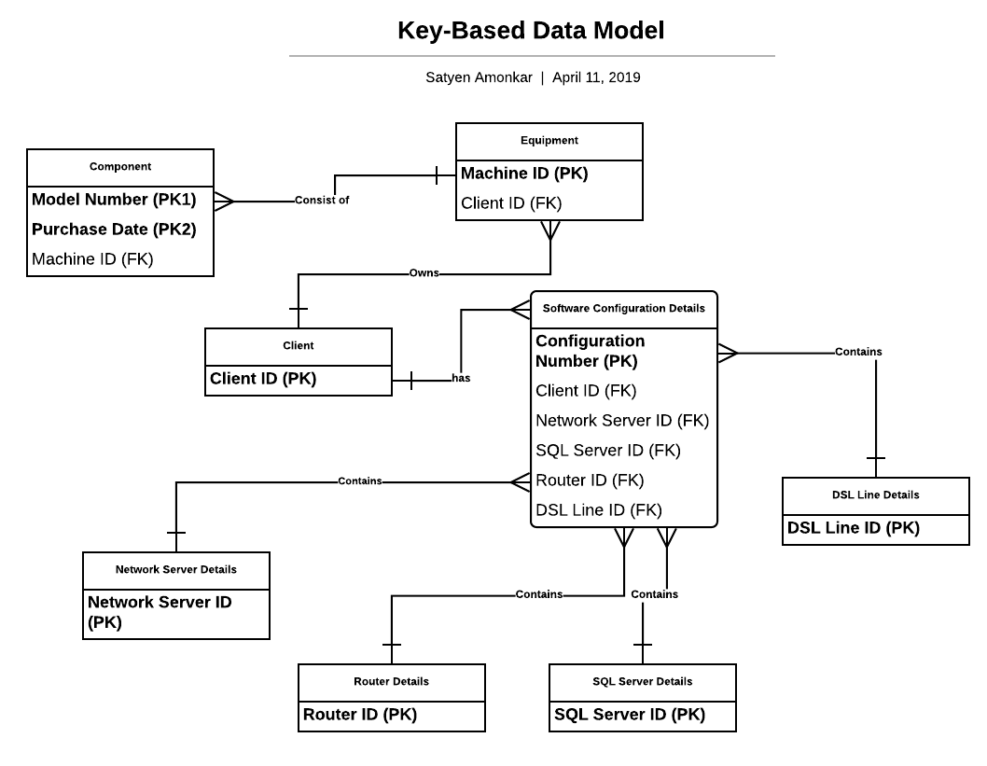

**Fully Attributed Data Model:**

